Today our primary task is to give an explanation of the sung Mass, and then we will have much time devoted to the practicing of the Mass, the new Mass in the English Missal of 2010, according to the current guidelines.

But, since the training that is necessary to be able to sing the Mass well will be an endeavor that is only begun today and will hopefully continue for each of you, I will first give a brief general introduction to the role of Sacred Music in the Holy Liturgy, to give you a reason, if you should need one, to further your study and training on this topic, as priests of the Holy Mass. I would like for us to consider within the larger topic, where so much could be said, primarily one thing: Unity.

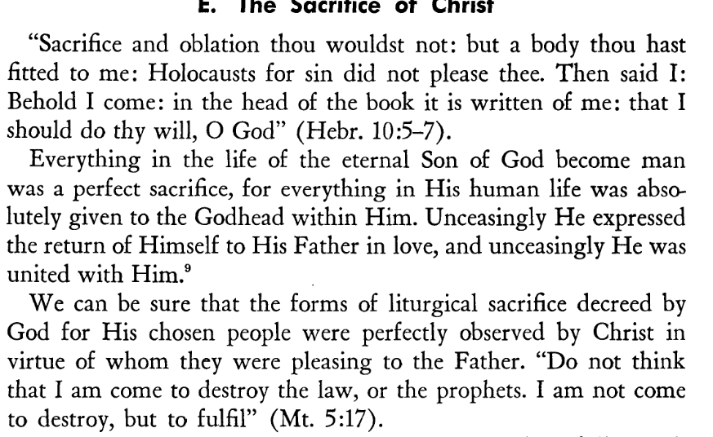
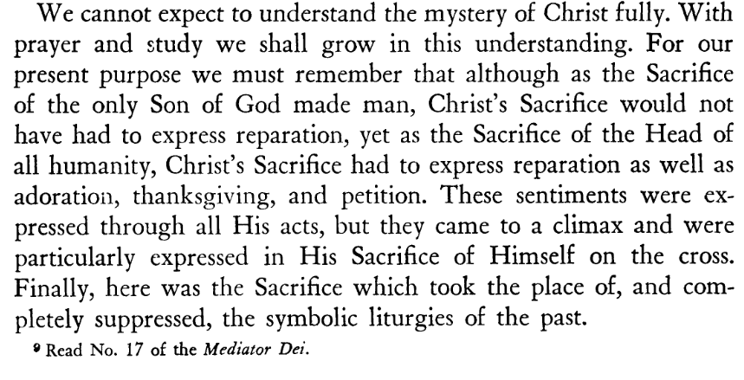
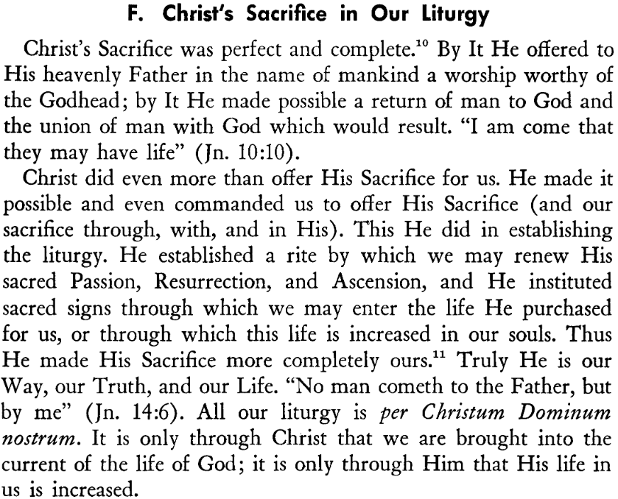

What I read is from a book called Singing the Liturgy written in 1955, and I think gives a proper context to place our current discussion of the subject. Per Christum Dominum Nostrum, by the ministry of the Church do we assess all the elements of that which enters the Holy Temple and forms a part of the Holy Liturgy. What a glorious Act of our Supreme Head, what a glorious drama that we may play a part!

The Holy Liturgy is the prayer of Christ, the Head, and of His whole Church, He who came to repair the wrong, to open heaven and draw all men unto himself. Therefore, the ministers of the liturgy should have holy indifference and submission to the will of the Church in their approach and readings of the rubrics, in the context of the continuity of tradition that the Church has beautifully laid out through the centuries in her Liturgical Expression, her public and corporate worship, realizing it is not the private prayer of any individual but the fulfillment of the One Glorious Saving Action.

We can certainly observe the wisdom of the Church through the ages in her slow and organic development of the Liturgy, and she is not without a whole host of discussion on Sacred Music’s application to the Holy Mass. Almost every century has seen documentation and discussion of the role of music because of its power above any other art to sway the emotions through her expression, but also to form the passions; and to elevate the common voice to that which is sacred. The Angels sing “Holy Holy” in heaven without end. There, there is no longer need for casual conversation with mere speech. When face to face with our Divine Creator, our voices will soar with joy in song, even the song of the heart, as Scriptures say.

According to Pope St. Pius X in his Motu Proprio on Sacred Music in 1903, Tra le Sollicitudine, the Criteria for Sacred Music are three: holiness, beauty of form, and universality. Judging music solely according to the first two criteria of “holiness” and “beauty or goodness of form”, especially when taken out of context, could seem subjective, according to time, place, or culture, but when taken together with the third, universality, we have a quality of sacred music that transcends place and time for that general aim – the “Glorification of God and edification and sanctification of the people.” Using this criteria of universality, we can see that today, over a century later, the progress of Sacred Music can be marked by its fruits of unity or disunity. Sadly, today we can go from one parish to another and find very different approaches to music within the Holy Liturgy. Also, within the same parish, there may be different communities, “Youth Mass”, “LifeTeen”, “Spanish Mass” “Latin Mass”. All these distinctions carry with them different musical “styles”. Is this in keeping with the mind of the Church on Sacred Music? And who decides what style of music is best suited to the Holy Liturgy? The hymns that I choose at Mass certainly reflect my own personal taste and style. Are the fruits of unity or disunity in this approach different from what they could be if each entrance into the Holy Missa in cantu would employ the full use of the Church’s musical resources, that which as a Good Mother, she has suggested?

Pope Benedict XVI – “One thing should be clear: the liturgy must not be a terrain for experimenting with theological hypotheses. Too rapidly, in these last decades, the ideas of experts have entered into liturgical practice, often also by-passing ecclesiastical authority, through the channel of commissions which have been able to diffuse at an international level their “consensus of the moment,” and practically turn it into laws for liturgical activity. The liturgy derives its greatness from what it is, not from what we make of it. Our participation is, of course, necessary, but as a means of inserting ourselves humbly into the spirit of the liturgy, and of serving Him Who is the true subject of the liturgy: Jesus Christ. The liturgy is not an expression of the consciousness of a community which, in any case, is diffuse and changing. It is revelation received in faith and prayer, and its measure is consequently the faith of the Church, in which revelation is received. The forms which are given to the liturgy can vary according to the place and time, just as the rites are diverse. What is essential is the link to the Church which for her part, is united by faith in the Lord. The obedience of faith guarantees the unity of the liturgy, beyond the frontiers of place and time, and so lets us experience the unity of the Church, the Church as the homeland of the heart. (Pope Benedict XVI, “Theology of Liturgy” 2001)

If we are truly indifferent to the guidelines of the Church, in the area of Sacred Music, no matter what place, what time, what the group of people gathered, the Mass should be holy, beautiful and universal. All of the element which are diffuse and changing according to the times, have as their link to the Church the unity of the rubrics, the unity of obedience to Christ the Supreme Founder of the Rite.

Pope Pius XII in Mediator Dei says– “With docile hearts, then, let all Christians hearken to the voice of their Common Father, who would have them, each and every one, intimately united with him as they approach the altar of God, professing the same faith, obedient to the same law, sharing in the same Sacrifice with a single intention and one sole desire.”

The Liturgy of the Church and her music are One. Historically, the music is laid out according to distinctions of spoken, sung and solemn. Knowing what a Sung Mass is from the Extraordinary Form, we see that the Mass is the music. The Music is the prayers and text of the Mass. The low Mass, we know, is somewhat a descendent of a more privatized prayer, for small groups, in extraordinary places, private Masses, early in the morning, etc. It is the sung Mass that more closely reflects the ancient tradition of public ritual worship. Jesus, Our Lord, obedient to Jewish law, fulfilled the singing of the hymns and rituals, as did the Apostles. “And having sung a hymn, they went forth to the Mount of Olives.” Mt. 26:30, “Let the Word of Christ dwell in you richly, teaching and admonishing one another in all wisdom, singing psalms hymns and spiritual canticles. Col 3:16)

The Sung Mass exists for the elevation of the voice both of the priest and the people – to go beyond the ordinary, beyond conversation, and thereby enter into the holy language of ritual Sacrifice to God. Music itself, singing, is a language all its own, a different language than speech altogether, as it functions from a different part of the brain. When sung, the dialogue between priest and people in this elevated language becomes the song of the bridegroom with the bride. Also when the priest is offering prayers or orations to God the Father on the Church’s behalf, then it is clear to all that this is of utmost importance and is so mentioned in the GIRM: 30. “Among those things assigned to the Priest, the prime place is occupied by the Eucharistic Prayer, which is the high point of the whole celebration. Next are the orations, that is to say, the Collect, the Prayer over the Offerings, and the Prayer after Communion. These prayers are addressed to God by the Priest who presides over the assembly in the person of Christ, in the name of the entire holy people and of all present. Hence they are rightly called the “presidential prayers.”

Music has both an expressive and formative quality. We often think of music at Mass as fulfilling the expressive part– that which adds something, sometimes even so much so that we pause the Mass to insert something musical to give greater meaning to that which is being done. Of course in our humility, we should know that nothing we can ever do will increase the Action of the Holy Mass! Within the Holy Liturgy, when referring to music, the Church refers almost exclusively to vocal prayer, or vocal music, which is made up of words. The music is the communication to God through the voice of the priest and his people. “To sing is a lover’s thing” says St. Augustine. (*see further below) To sing is to pray from the heart. The Vatican II documents, Sacrosanctum Concilium, Musicam Sacram rightfully recognize the Church’s ancient understand of music as formative. Giving structure to the emotions of the heart, it forms a necessary and integral part of the worship of the Church throughout her history. “Sacred Music as an integral part of the solemn liturgy shares in its general purpose, which is the glory of God and the sanctification and edification of the faithful.” (Pope St. Pius X, Tra le sollicitudine, No. 1) The music of the Mass is the Mass. The Church has asked, time and again, that, in the model of Gregorian chant, where words and music are closely united in prayerful expression, we sing the Mass at Mass, not sing songs at Mass.

The singing of the Church comes ultimately out of love. It is the utter depth of love that produces the singing. "Cantare amantis est", says St. Augustine, singing is a lover's thing. In so saying, we come again to the trinitarian interpretation of Church music. The Holy Spirit is love, and it is he who produces the singing. He is the Spirit of Christ, the Spirit who draws us into love for Christ and so leads to the Father. (Pope Benedict XVI, The Spirit of the Liturgy, p 142)
General Instruction of the Roman Missal - 2010
38. In texts that are to be pronounced in a loud and clear voice, whether by the Priest or the Deacon, or by a reader, or by everyone, the voice should correspond to the genre of the text itself…
Therefore, in the rubrics and in the norms that follow, words such as “say” and “proclaim” are to be understood either of singing or of reciting, with due regard for the principles stated here above.
40. Great importance should therefore be attached to the use of singing in the celebration of the Mass, with due consideration for the culture of peoples and abilities of each liturgical assembly. Although it is not always necessary (e.g., in weekday Masses) to sing all the texts that are in principle meant to be sung, every care should be taken that singing by the ministers and the people not be absent in celebrations that occur on Sundays and on Holydays of Obligation.
However, in the choosing of the parts actually to be sung, preference is to be given to those that are of greater importance and especially to those which are to be sung by the Priest or the Deacon or a reader, with the people replying, or by the Priest and people together.[49]
Musicam Sacram, 1967

27. “On Sundays and Feasts the Missa in cantu (sung Mass) is to be preferred, even several times on the same day.”

28. “The distinction of Solemn, Sung and Read Mass is to be retained…”
To make it easier to implement the full participation of the Sung Mass, however, the Council Fathers laid out degrees of things to be sung, and says “The First degree may be done in whole or in part, but those belonging to the 2nd and 3rd degree should never be done without the 1st degree.”

Documents for Further Study:
Mediator Dei (Pope Pius XII)
Chirograph on Sacred Music (Pope St. John Paul II, 2003)
Motu Proprio: Tra Le Sollecitudini (1903)
Introduction to the 1974 Graduale/Ordo Cantus Missae (in English)
Letter accompanying Summorum Pontificum
Letter to Artists (Pope St. John Paul II, 1999)
Musicae Sacrae, Enclycical of Pope Piux XII (1955)
Musicam Sacram, Vatican II (1967)
Sacrosanctum Concilium (1963) – musical formation of clergy specifically: Art. 116, 118, 119, 120
Sacramentum Caritatis (2007)

Books for further study:
The Organic Development of the Liturgy (Alcuin Reid w/ foreword by Card. Ratzinger)
The Mass of the Roman Rite: The Origins and Development (Joseph Jungmann)
Ceremonies of the Modern Roman Rite (Bishop Peter Elliot)
Catholic Music Through the Ages (Edward Schaefer)
Crux et Cithara (collection of essays, edited by Fr. Richard Skeris)
Catholic Church Music (Richard Terry, 1907)
The Musical Shape of the Liturgy (William Mahrt)
The Spirit of the Liturgy (Ratzinger)
Ceremonies of the Roman Rite Described (Adrian Fortescue)

“To Sing is a Lover’s Thing” - St. Augustine

It is good to give Thanks to the Lord
To make music to your name, O Most High,
To proclaim your love in the morning
And your truth in the watches of the night. (Ps. 92)

In speaking on the language of the Song of Songs, St. Teresa of Avila reminds us how frail our minds are in understanding the love of God. “O my Lord, how poorly we profit from the blessing You grant us! You seek ways and means and you devise plans to show Your love for us; we, inexperienced in loving You, esteem this so poorly…”

If the language of love is song, we can not sing when downcast by sin, by sadness, captives “in a foreign land”. St. Francis de Sales says, “Anyone who is a slave to courtly favors, the prizes of law, or the honors of war is thoroughly distracted. It is not possible to sing a hymn of heavenly love.”

On the contrary, those in heaven, in total freedom, sing unceasingly, “Holy Holy”.

The fruit of love is the other virtues, which flow from that perfect stem. “Love is insatiable in its desire to bear fruit.”

“The righteous will flourish like a palm tree, they will grow like a cedar of Lebanon; planted in the house of the Lord they will flourish in the courts of our God.”

And so we speak of the language of love, when our mouths utter the praise of this Love, it comes forth from the heart in song. How dull would be the words of the lover if not sung in a tender serenade?

And so St. Teresa says, “… upon hearing an explanation of those loving delights with which the bride communed with God…there was so much laughter, and what was said was so poorly taken, that I was shocked. He was speaking about love since the sermon was on Maundy Thursday, when one shouldn’t be speaking of anything else. And I see clearly that the reason for not understanding is the one I mentioned (that we practice so poorly the love of God), for it doesn’t seem to us possible for a soul to commune in such a way with God…[yet] He has left a salutary remedy to souls that love Him with a fervent love because they understand and see that it is possible for God to humble himself so much.” (Meditations on the Song of Songs, No. 5)

The singing of the Church comes ultimately out of love. It is the utter depth of love that produces the singing. "Cantare amantis est", says St. Augustine, singing is a lover's thing. In so saying, we come again to the trinitarian interpretation of Church music. The Holy Spirit is love, and it is he who produces the singing. He is the Spirit of Christ, the Spirit who draws us into love for Christ and so leads to the Father. (Pope Benedict XVI, The Spirit of the Liturgy, p 142)

